~ Rivergate ~
13263 Apdon Court, Richmond, Virginia 23238
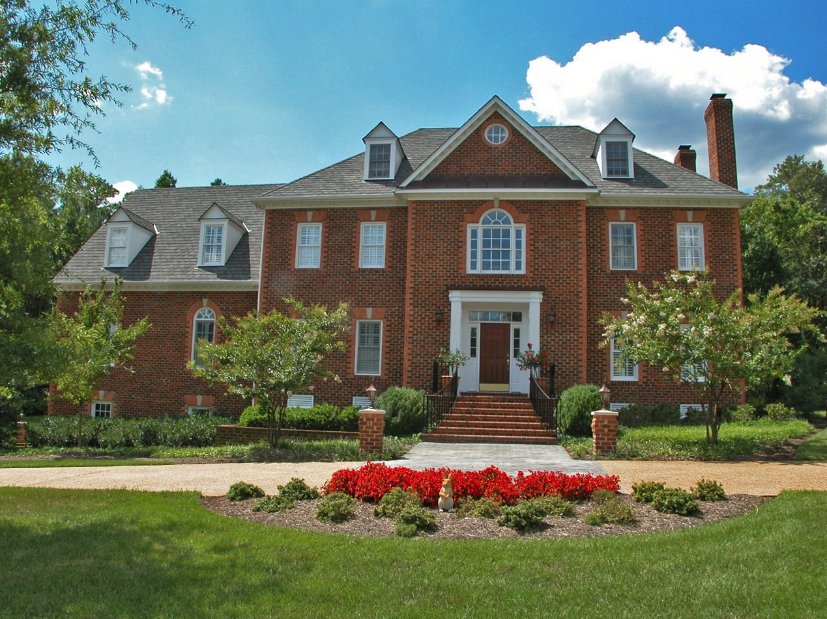

Represented by Joyner Fine Properties
Richard Bower @ 967-2777
See this “Featured Property” at www.RichardBower.com

Rivergate
Rivergate is a private, gated, lake community with a prestigious address on River Road. This community offers heavily wooded homesites from two to six acres. The sparkling waters of the forty-acre lake add a special touch to this magnificent community.

Because privacy is of the utmost importance in this 368-acre community, there will be only 67 custom built homes. You will find a strong sense of security, with two gated entrances and private roads. Rivergate is a secluded oasis just inside the Goochland County line, and is convenient to Innsbrook, the West End or downtown.

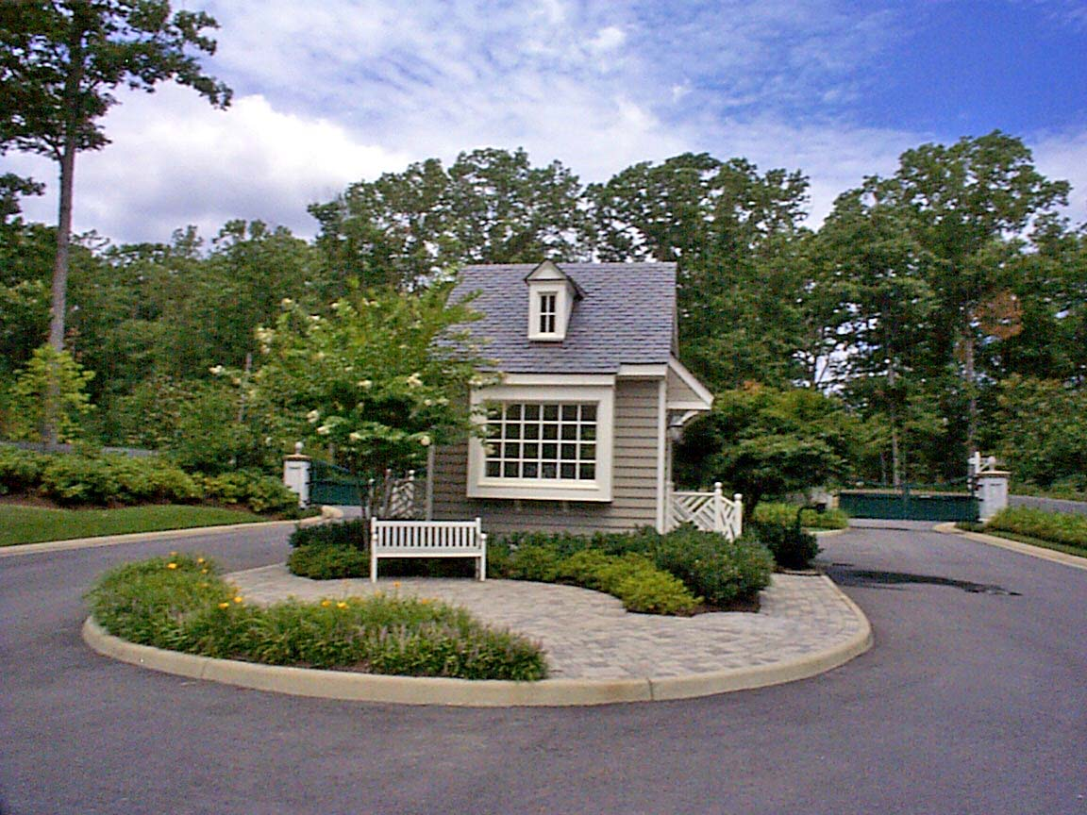

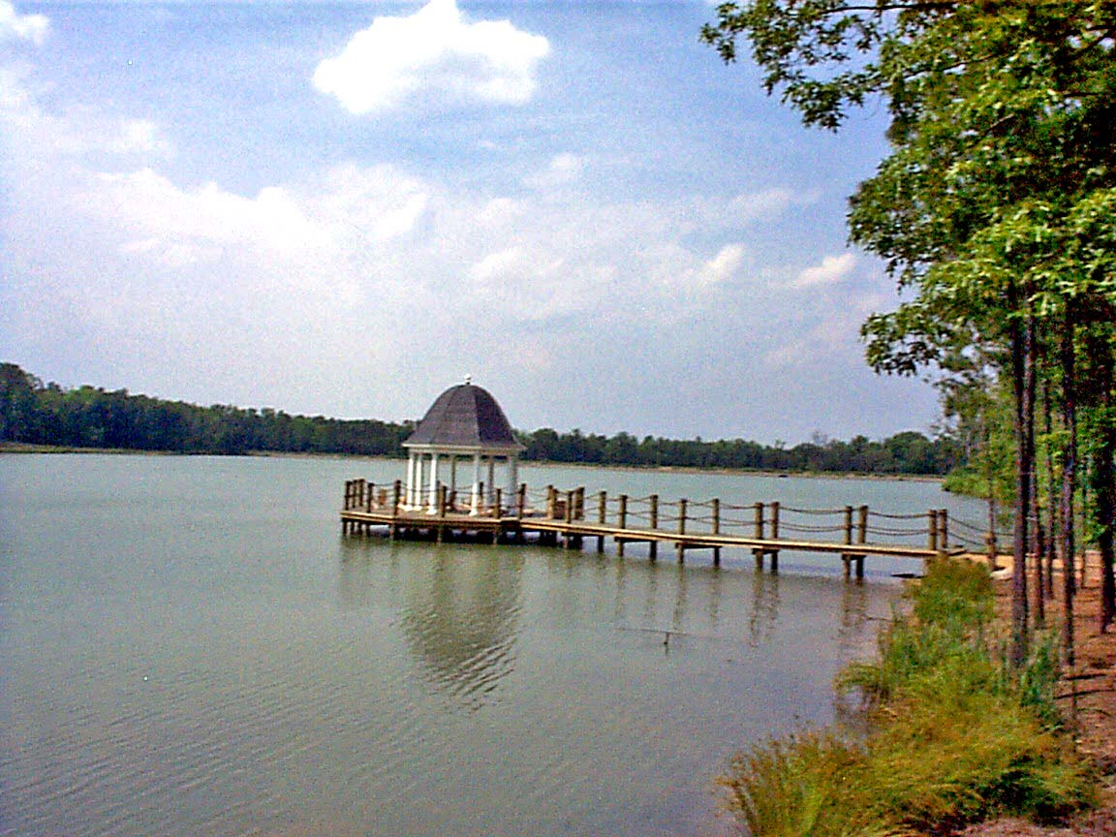

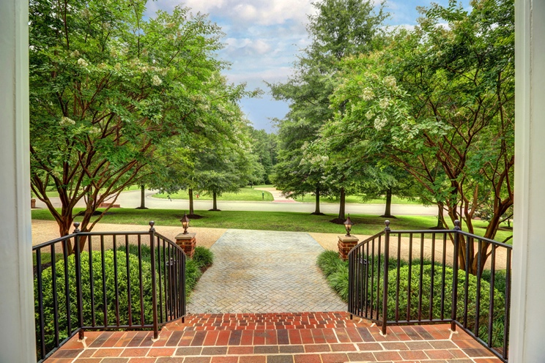
Offering Price: $1,150,000
Owner: Garnet E and Diane K Pigden
Legal: Lot 22, Sec 1, Rivergate
Acreage: Per county tax records, 2.147 acres
Year Built: 1998
Taxes: Per county records, 2016 taxes were $5,923
Finished Sq. Footage: Per appraisal, finished sqft is 6,079 (5,756 + 323 basement gym)
Schools: Randolph Elementary, Goochland Middle, Goochland High School
Homeowners’ Association: $3,000 yearly; services include:
- Security gate with answering service, limiting traffic to those authorized to enter
- Security and management of the lake and Gazebo Park
- Architecture compliance and supervision; managing all the covenant agreements pertaining to resident
- Street maintenance and snow removal
Exterior Features
- Brick (3 sides) – exceptionally nice craftsmanship – and Hardi-Plank (rear) exterior
- Grand Manor roof
- Westminster door chimes upstairs and downstairs
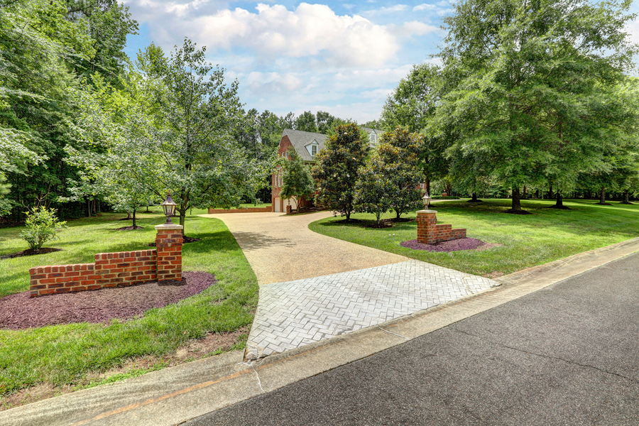
- Aggregate circular drive and driveway to side-load garages with abundant guest parking
- Brick entry pillars - lighted driveways and lighted garage area with pillars
- Mature landscaping with private side and rear yards
- Exterior lights on brick pedestals
- Rear deck with doors into the Family Room/Library, Breakfast area, and Florida Room
Interior Features
- Three-stop elevator with access doors into the garage, Family Room/Library, 2nd floor bedroom
- 9-ft ceilings on the first floor
- Hardwood floors on the first floor, master bedroom and second floor hallway
- Two brick fireplaces (gas logs) – living room and Great Room
- Two staircases between the first and second floors
- Plantation Shutters on windows and doors
Mechanicals:
- Three-zone HVAC with natural gas heat and central air conditioning on the first two levels and heat pump on the third floor
- Security system
- Double reverse osmosis drinking water (water and sewer provided by Goochland County)
- Natural gas provided by Columbia Gas
- 10-zone lawn irrigation system has its own well and covers all the grass areas
- Two gas hot water heaters (one in basement serves the first floor, one in attic has instant hot water and serves 2nd and 3rd floors)

Main Level
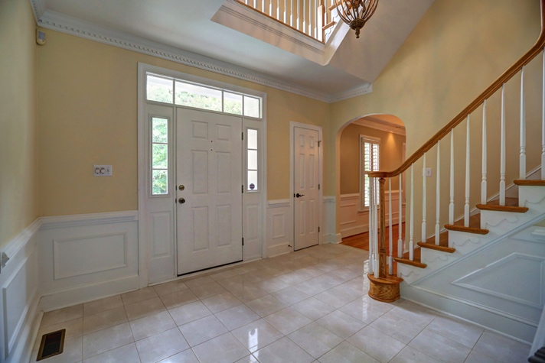
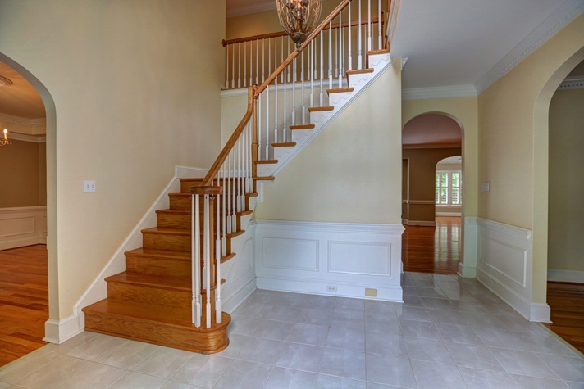

Foyer 13’5 x 9’10
Marbleized tile floor; coat closet; powder room; chair rail with picture frame moulding below; crown moulding with dentil detail

Powder Room
Pedestal sink; mirrored walls; marbleized floor

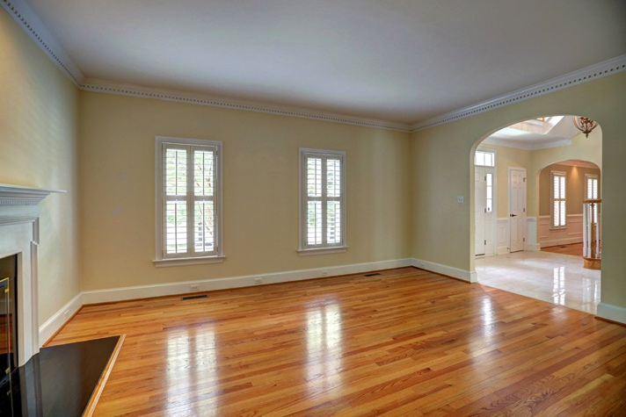

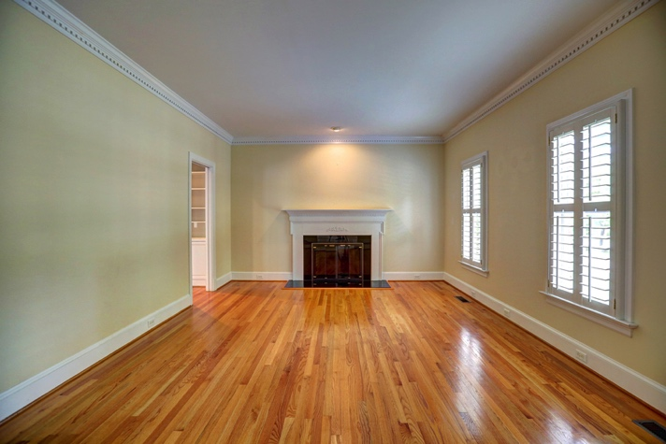

Living Room 17’2 x 13’5
Hardwood floor; crown moulding with dentil details; gas-log fireplace with marbleized hearth and surround and glass doors, custom carved mantle; recessed light; two windows with Plantation Shutters; arched opening to foyer and pocket door to Great Room

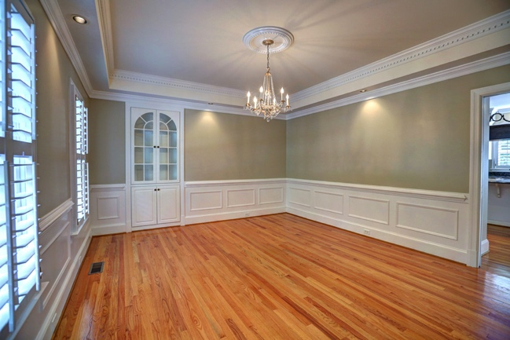
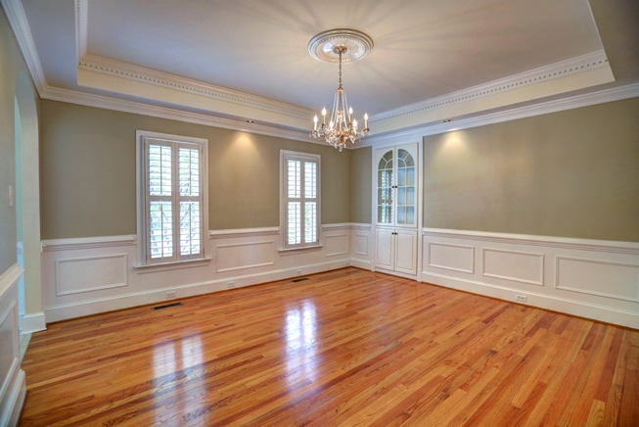

Dining Room 15’ x 13’6
Hardwood floor; built-in china closet; tray ceiling with recessed lights and crown moulding with dentil details; chair rail with picture frame moulding below; two windows with Plantation Shutters; pocket door to kitchen

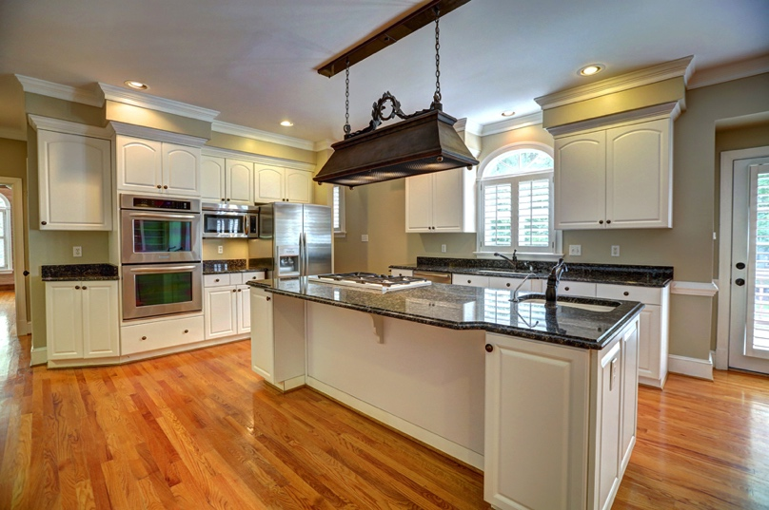
Kitchen & Breakfast Area 26’6 x 17’3
Hardwood floor; recessed lighting; granite tops, white raised panel cabinets with roll-out shelving, built-in desk and double pantry, central island with prep sink w/disposal, and gas cook top, double sink with disposal and “instant” hot water, window with Plantation Shutters over sink with fanlight above; Bosch stainless steel dishwasher, built-in Kitchen Aid microwave shelf, double built-in stainless steel Kitchen Aid convection ovens; stairway (window with Plantation Shutter) to second floor and stairway to basement; breakfast area is open to the kitchen and has a built-in buffet/bar with sink, wine storage cabinet, wine chiller, open to the Great Room; two full light doors (one fixed) and two windows with Plantation Shutters, all overlooking the private deck and back yard

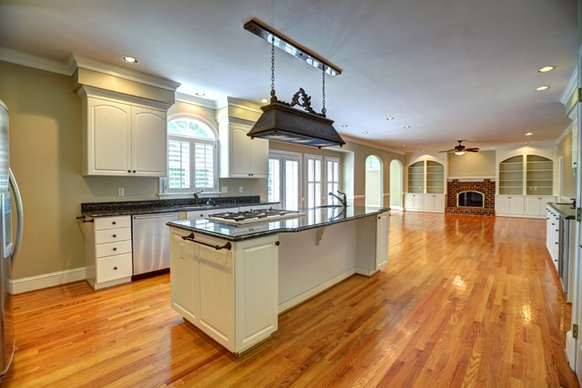
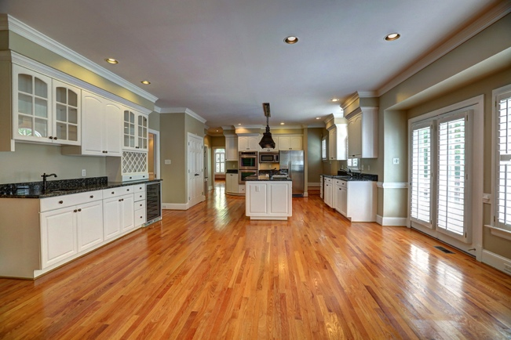
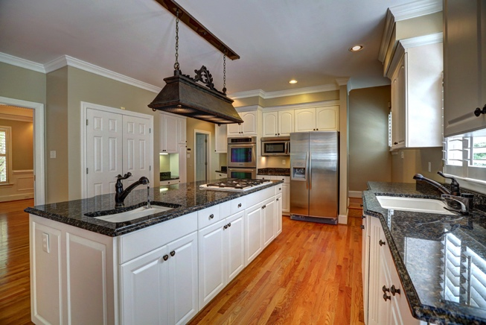

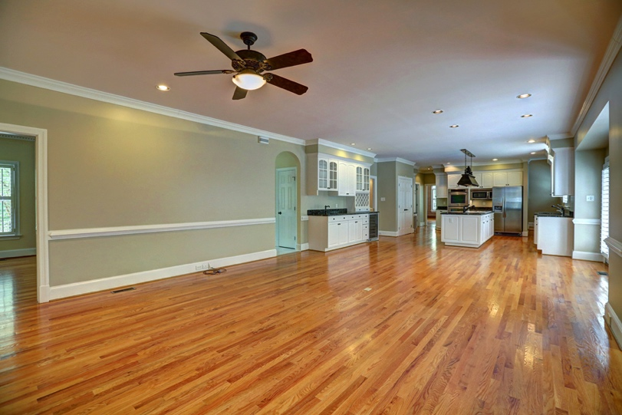
Family Room 18’ x 17’3
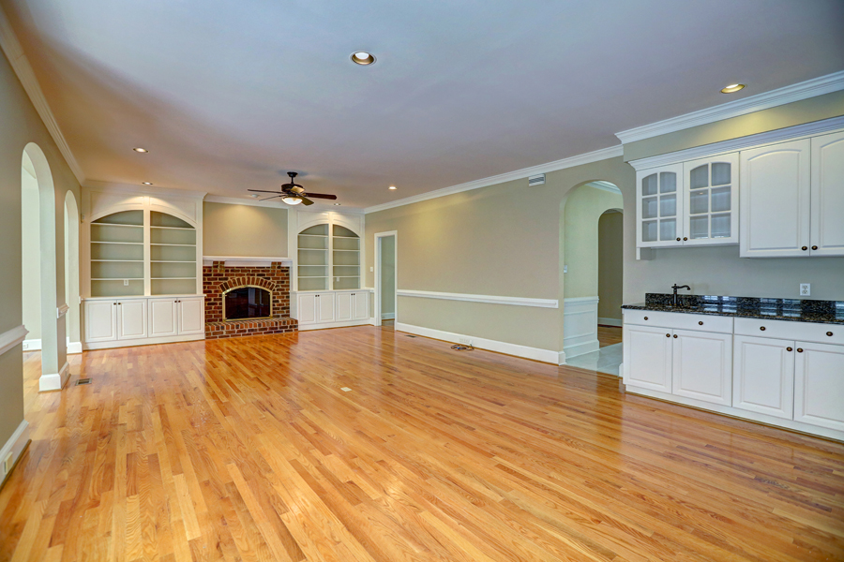
Open to the kitchen and breakfast area; hardwood floor; gas-log fireplace with raised brick hearth and surround, arched firebox with glass doors; built-in arched-topped cabinets with raised panel details and bookshelves; two arched openings to the Florida Room; pocket door to Living Room; ceiling fan with lights

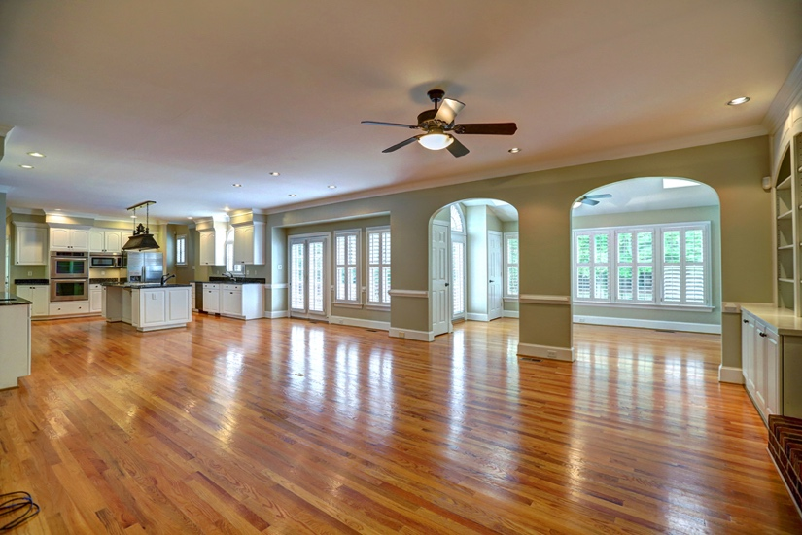

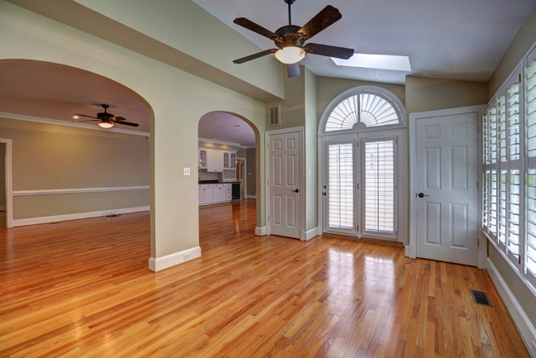

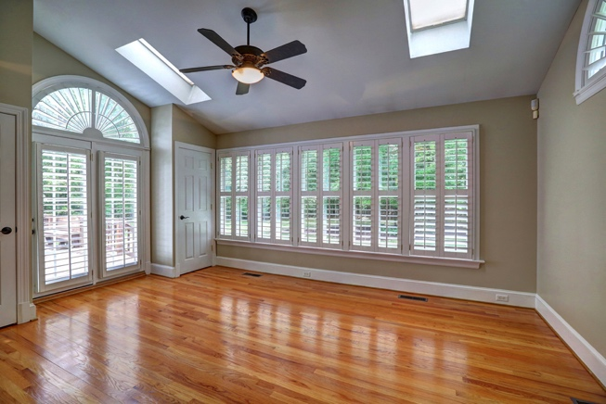
Florida Room 17’3 x 11’8
Hardwood floor; two closets; two full-light doors (one is fixed) with Plantation Shutters and fanlight above, opens to deck; matching fanlight window at opposite end of the room; full back wall of windows with Plantation Shutters; two arched openings to Great Room; vaulted ceiling with two skylights; ceiling fan with lights

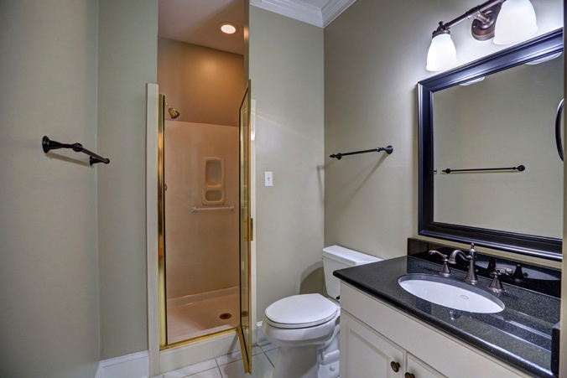
Full Bath
Tile floor; linen closet; new granite vanity top with white raised panel cabinet below; cultured marble shower with glass door; crown moulding
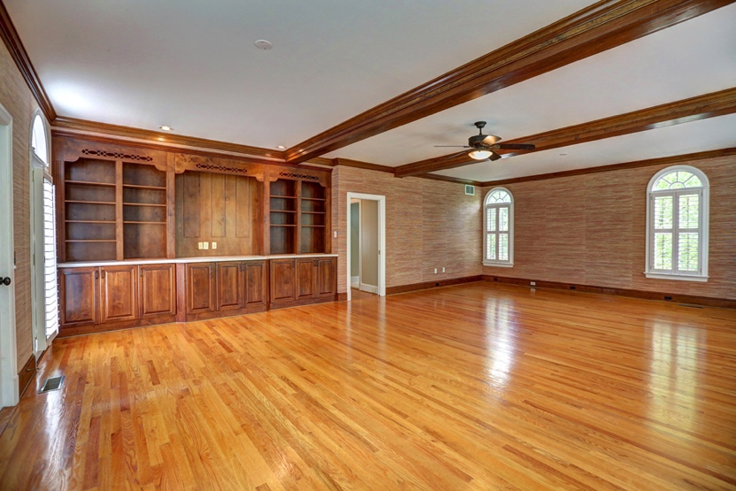
Recreation Room 29’3 x 19’10
Hardwood floor; exposed stained ceiling beams; ceiling fan; stained built-in bookshelves and storage cabinets; door to elevator; door to deck; crown moulding; 10 circle-head windows and matching door with Plantation Shutters; pocket door to hallway

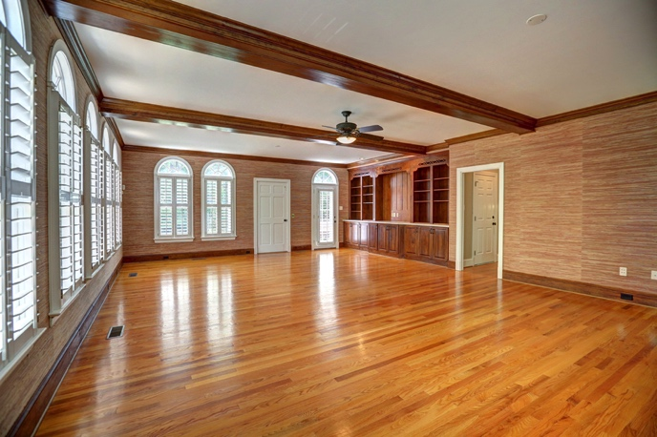

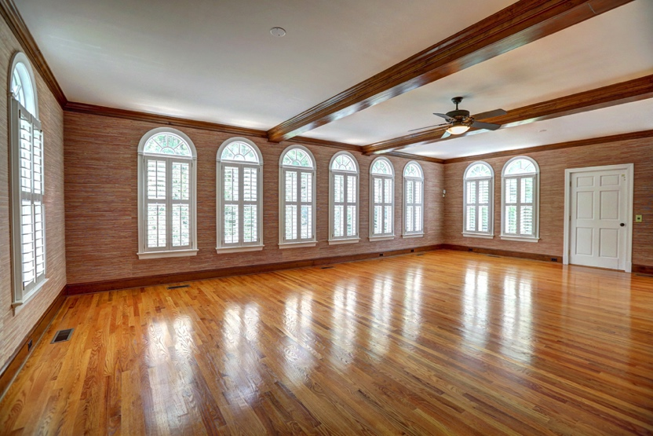

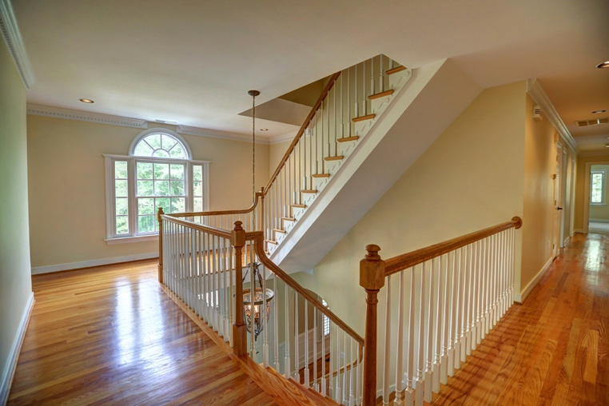

Second Level
Upper Landing
Hardwood floor; Palladian window; recessed lighting; crown moulding with dentil details; finished staircase to the third floor

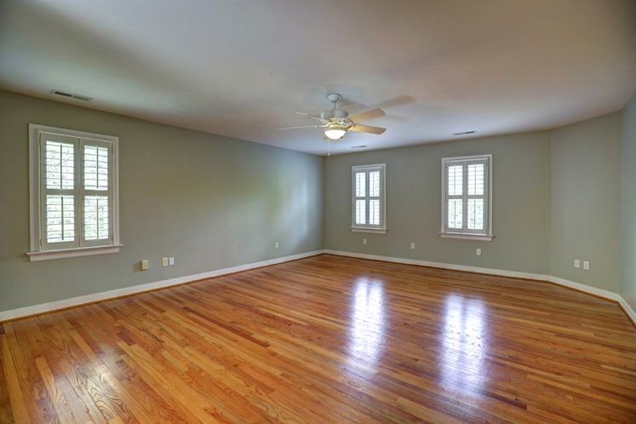
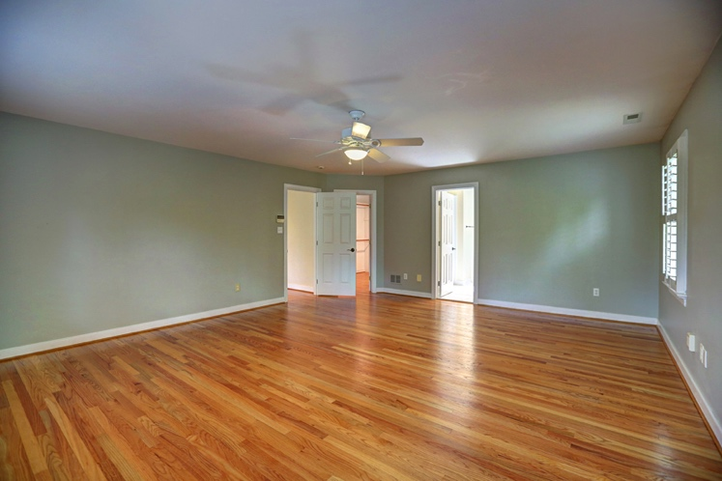
Master Bedroom 21’1 x 17’2
Hardwood floor; ceiling fan with lights; huge walk-in closet with doors into the bedroom and the master bathroom; 3 windows with Plantation Shutters

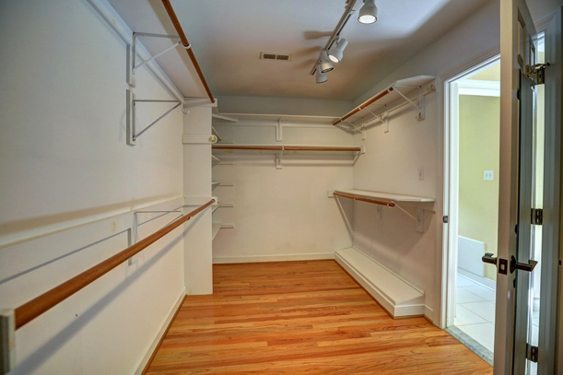
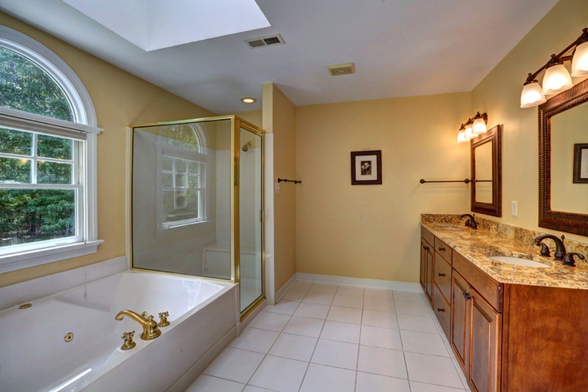
Master Bath
Tile floor; double granite vanity with new mirrors and stained cabinets below; linen closet; separate toilet room with window; jetted tub with window and half-circle window above; separate shower with glass door and built-in bench and grab bars

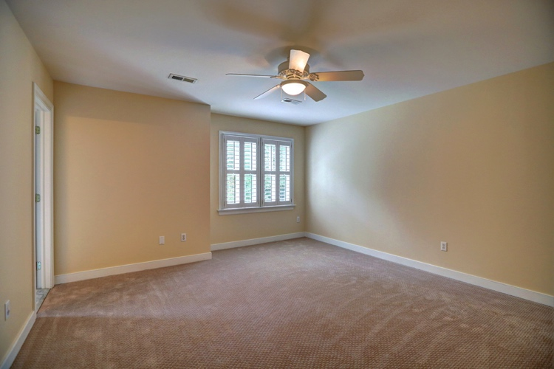

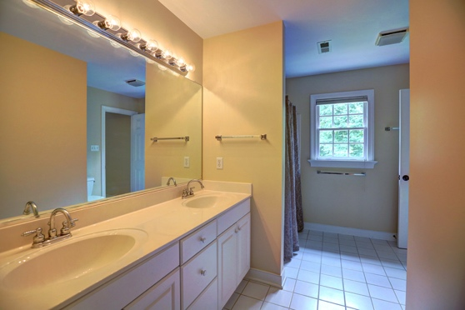
Bedroom 2 14’ x 12’10 (rear middle)
Wall-to-wall carpet; closet; ceiling fan with light; double window with Plantation Shutters; door to full bath

Full Bath (rear)
Tile floor; tub/shower with cultured marble surround and grab bars; double cultured marble vanity with white raised panel cabinets below; linen closet; door to BR #2 and door to hallway

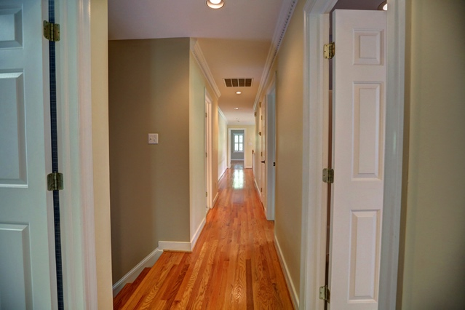
Hallway
Hardwood floor; crown moulding with dentil details; recessed lights; linen closet; back stairway to kitchen; to utility/laundry room

Bedroom 3 15’ x 13’4 (front middle)
Wall-to-wall carpet; double closet; ceiling fan with lights; two windows with Plantation Shutters

Full Bath (front, blue)
Tile floor; cultured marble vanity top with white raised panel cabinets below; tub / shower with cultured marble surround and grab bars; linen closet; window with Plantation Shutters; door to BR #4 and to hallway (could also serve BR #3)
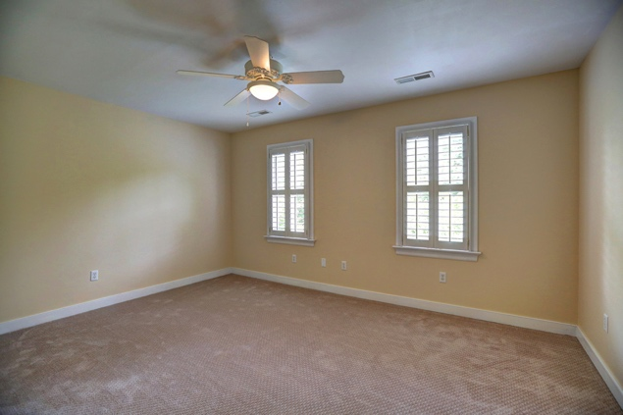

Bedroom 4 23’8 x 15’1
Wall-to-wall carpet; two double closets; window seat with storage below in dormer window with Plantation Shutters plus two more windows with Plantation Shutters; elevator access; ceiling fan with lights; door to full bathroom
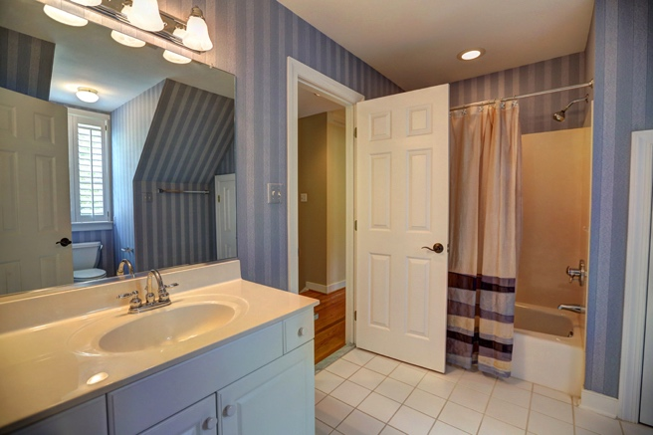

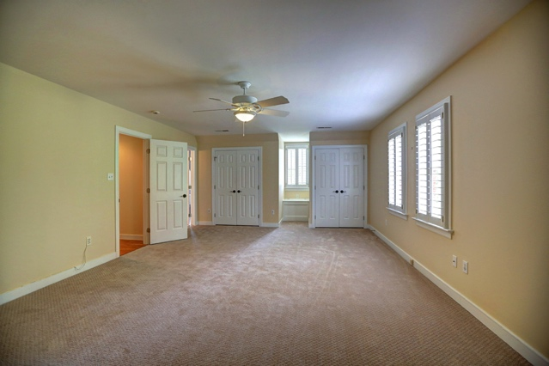

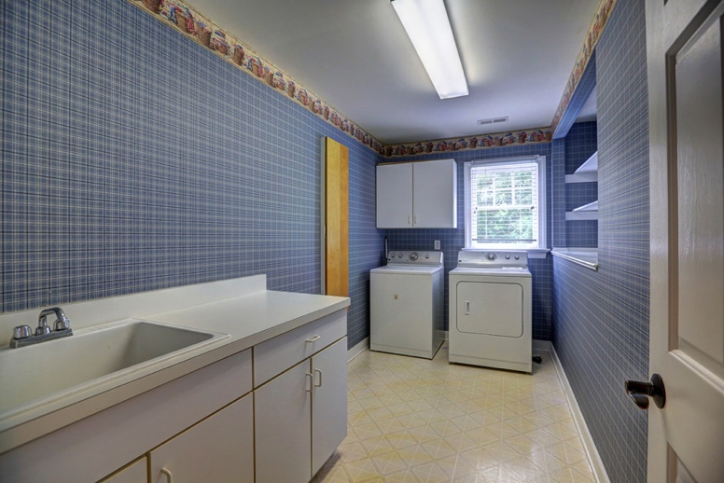

Laundry Room 12’9 x 6’3
Laundry sink and folding counter; built-in ironing board; recessed storage shelves; hanging cabinet; window; laundry hookups

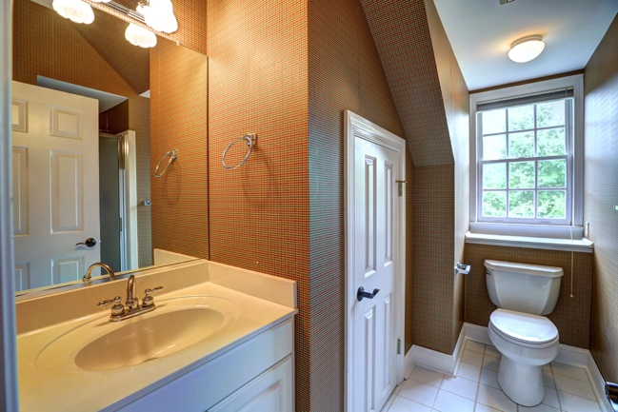
Third Level

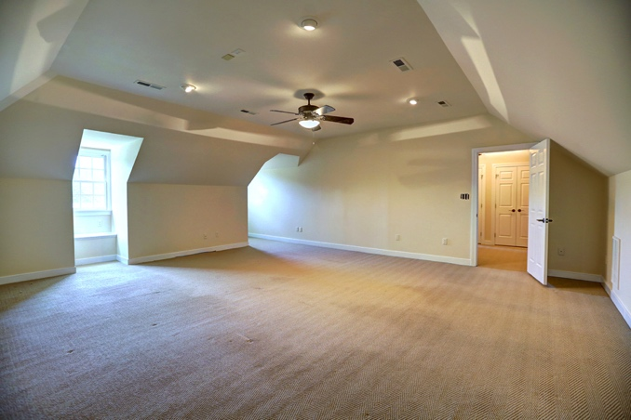
Full Bath
Tile floor; cultured marble vanity with storage cabinet below; linen closet; cultured marble shower with grab bar and glass door; window with built-in shelf below

Walk-in attic with thermostatic controlled exhaust fan
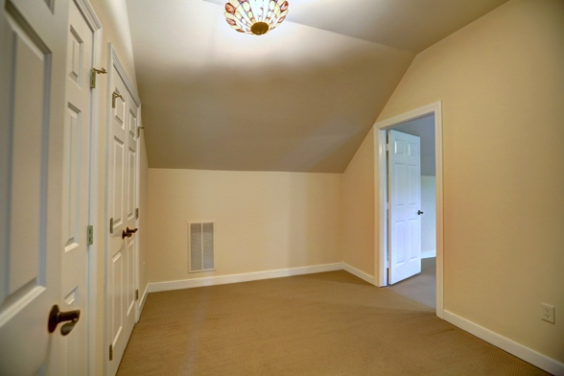
Office/Dressing Room 11’ x 9’2
Wall-to-wall carpet; two double closets; to rec room/bedroom

BR#5/Recreation Room 22’ x 21’2 (without dormer areas)
Wall-to-wall carpet; faux painted walls; recessed lights; ceiling fan with lights

Basement
Three-Car Garage
Three-car with electric door openers; pedestrian door to back yard; 3-level elevator access door; especially selected light fixtures; multiple custom built storage cabinets and closets on two walls, plus two additional closets, one with full size door and one with folding door; epoxy / polyurethane treatment on garage floor; walls sheet rocked and painted; two windows above shelving; door to exercise room

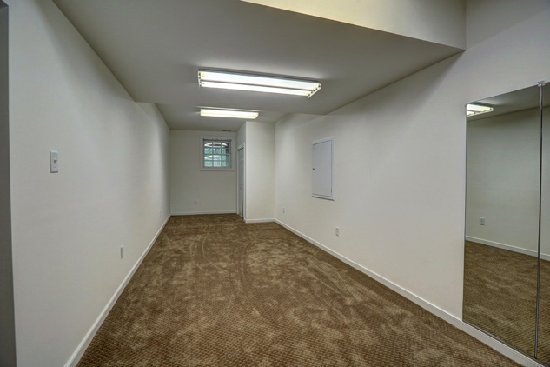
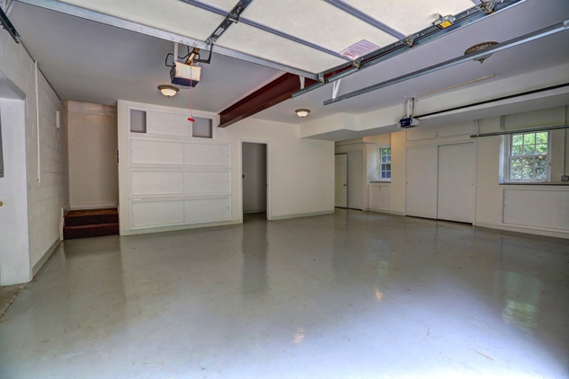

Exercise Room 29’8 x 9’3
Heated and cooled; wall-to-wall carpet; double closet; window

The information herein has been obtained from sources believed to be reliable
but is in no way warranted by us. Dimensions are approximate.

